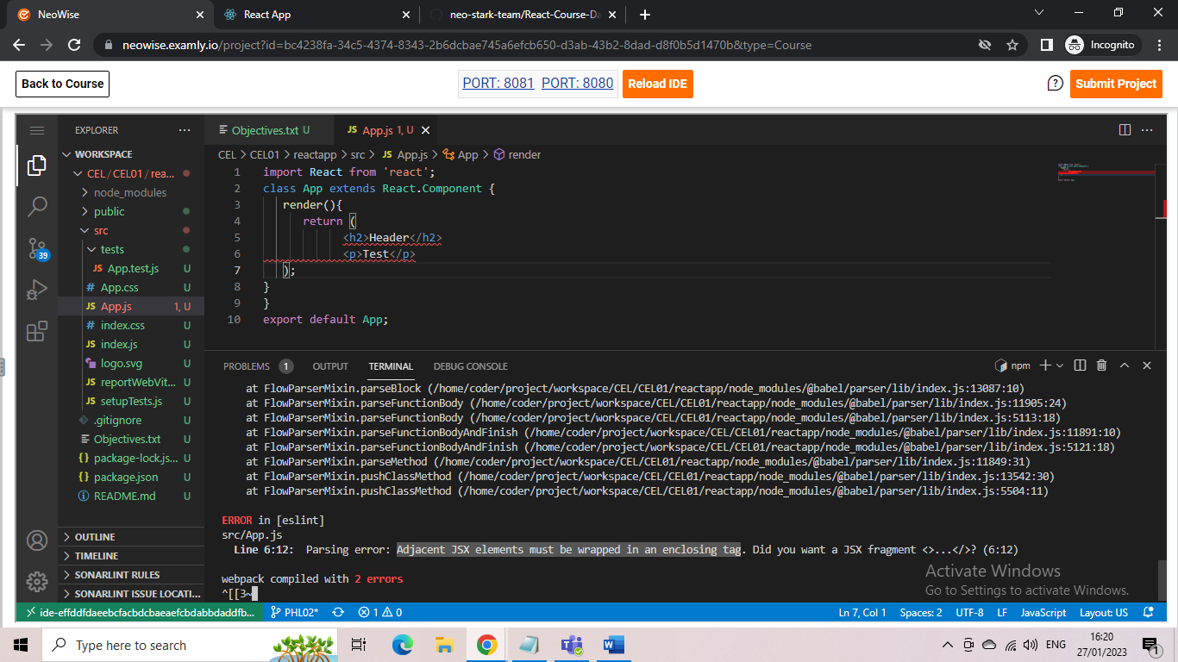
Generally, return statement in React renders method can have only one parent container. It cannot simply return multiple elements.

